**CLOUD FUNCTION CREATION**

1. Access the cloud console and go to cloud functions service from the project.

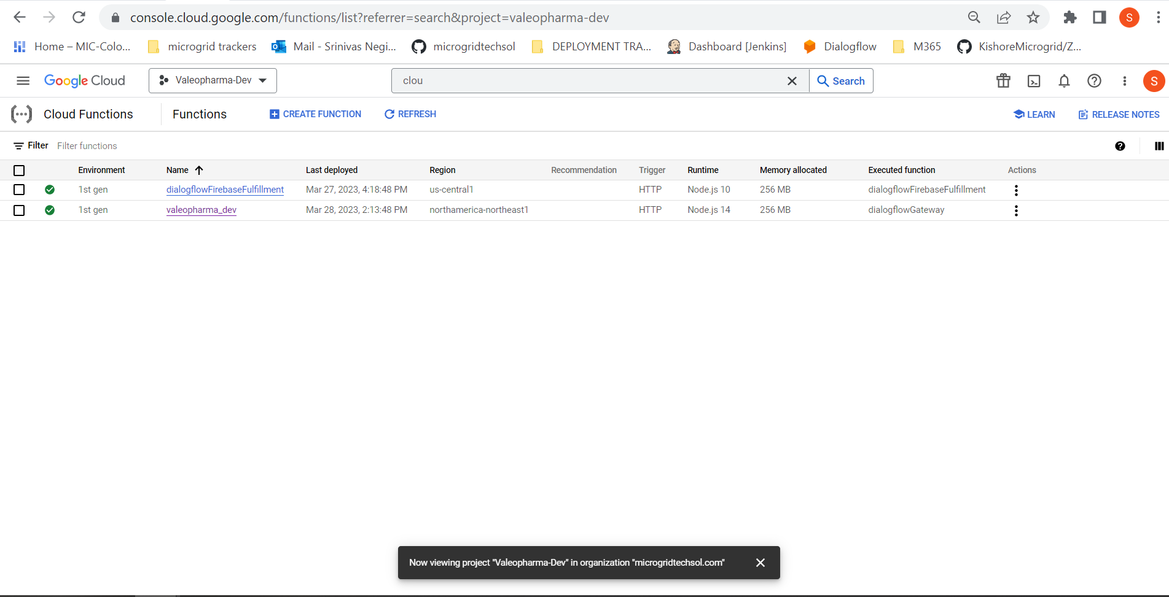

1. Click on the create cloud function.

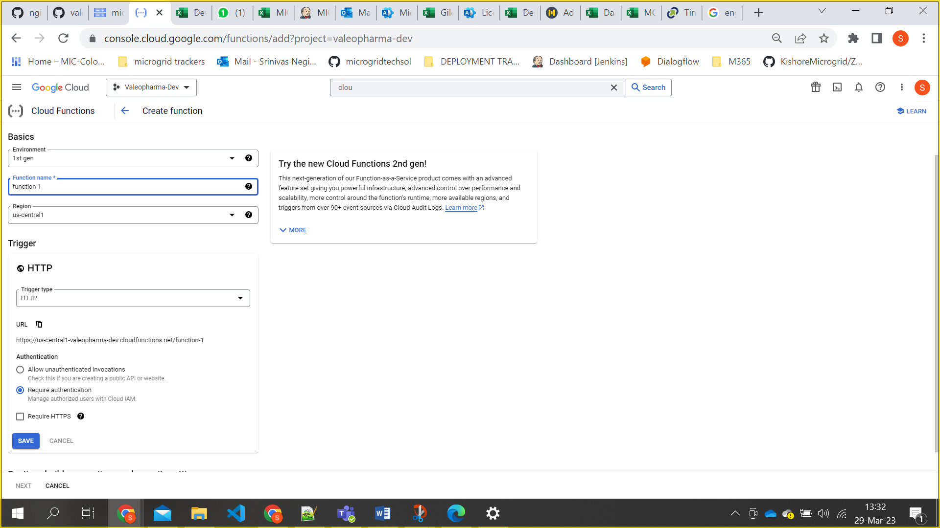

1. **Here** we have to follow the naming convention for Function name. [projectname_env]
2. Region need to selected according to project.
3. Uncheck the Request HTTPS and click on save button.

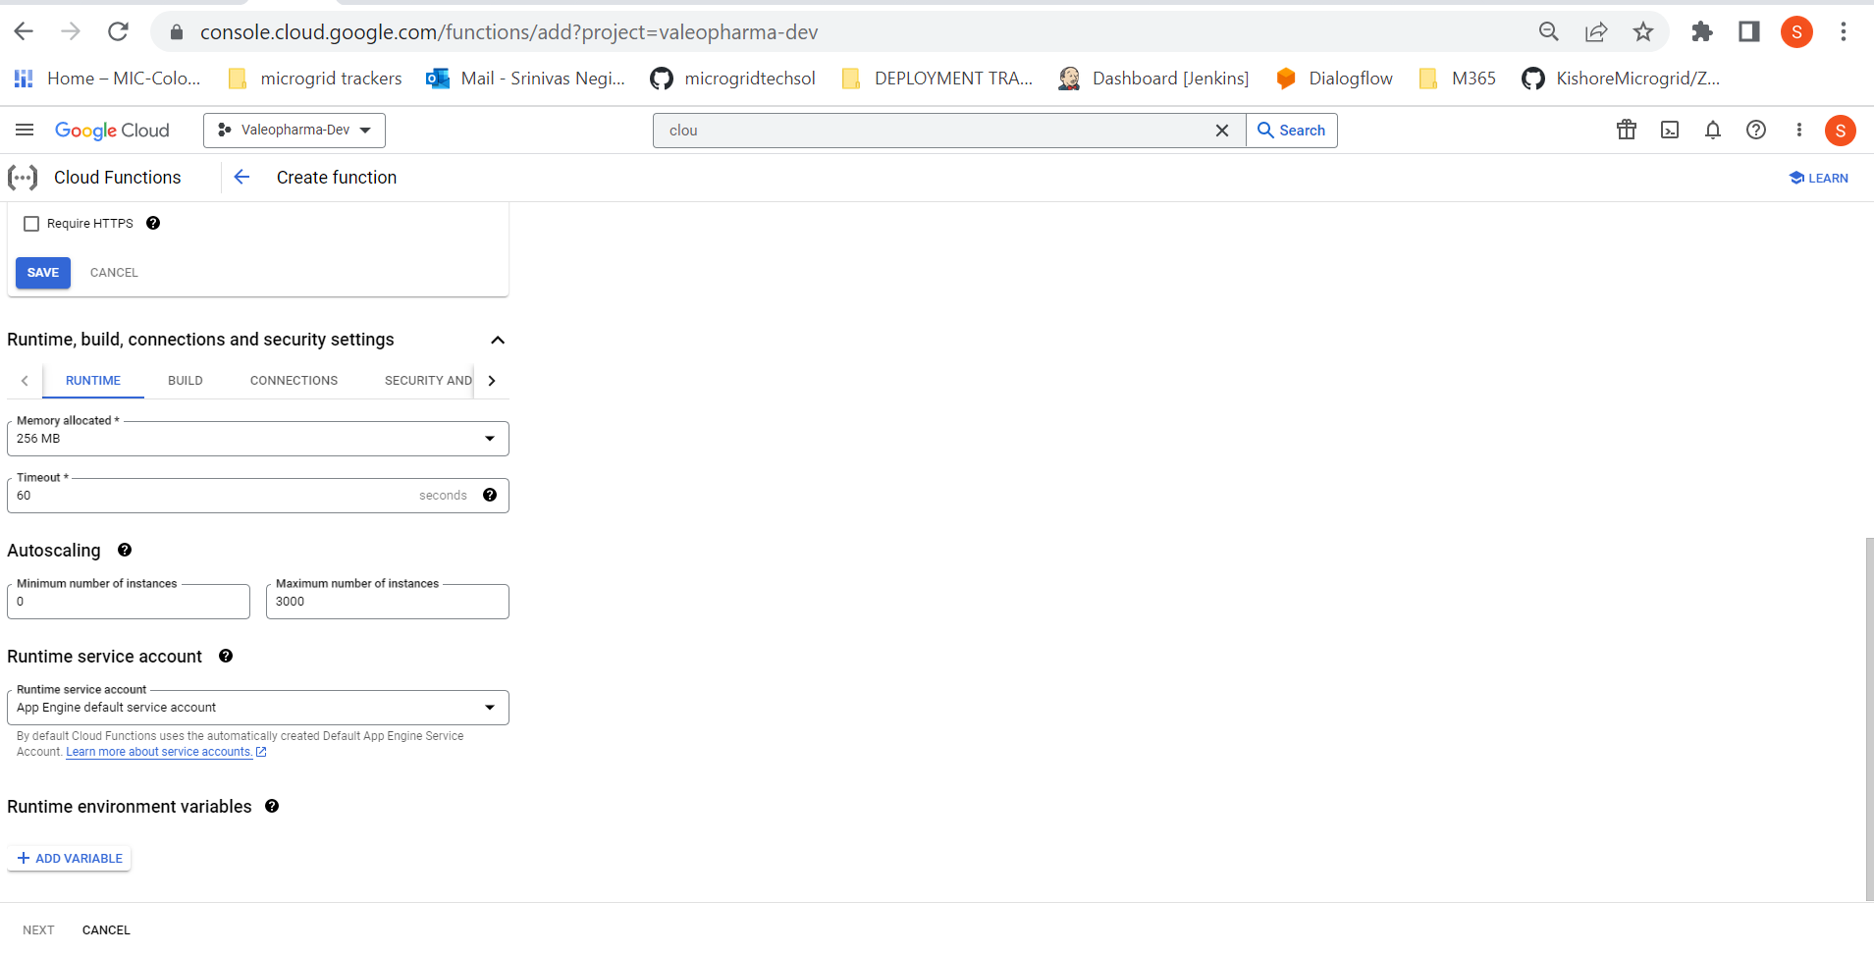

1. Change the maximum instance number from 3000 to 1000 and click on next button.

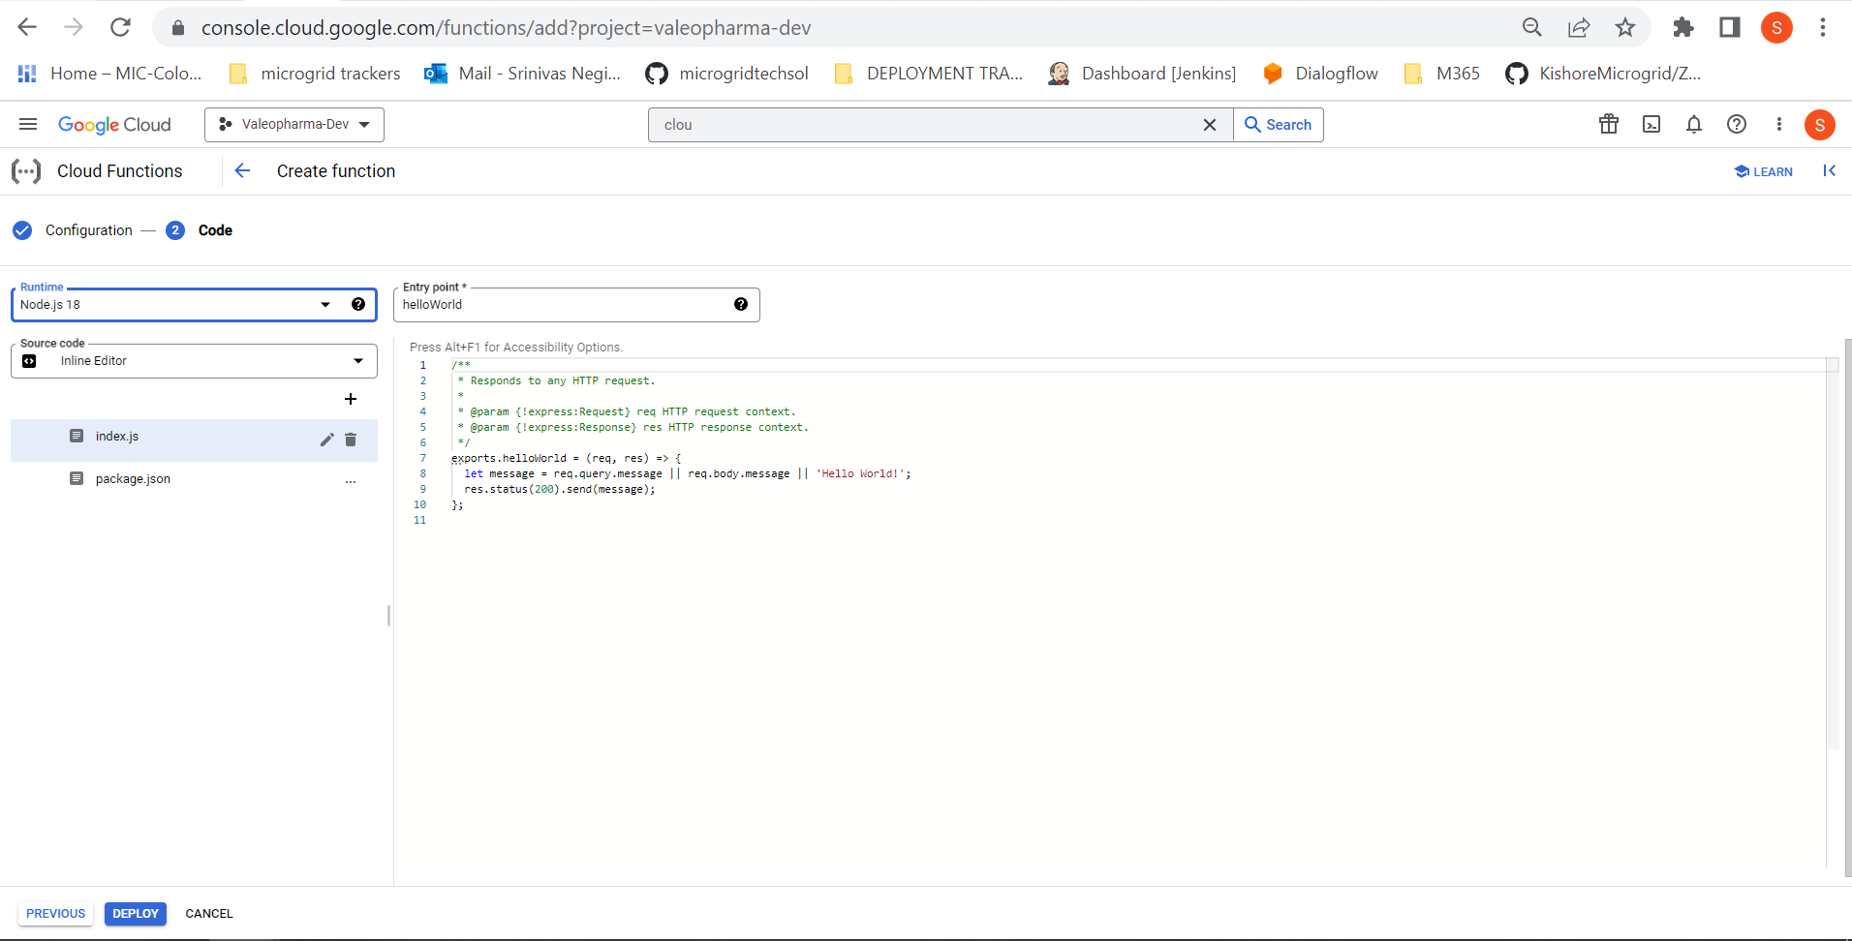

1. We need to select runtime that what we are using.
2. Entry point name is dialogflowGateway.
3. Generate a service account key as json file and copy the code and paste in index.js along with given code.

Please find the index.js and package.json files in the folder and place them as is it is by changing project details which will be provided in key.

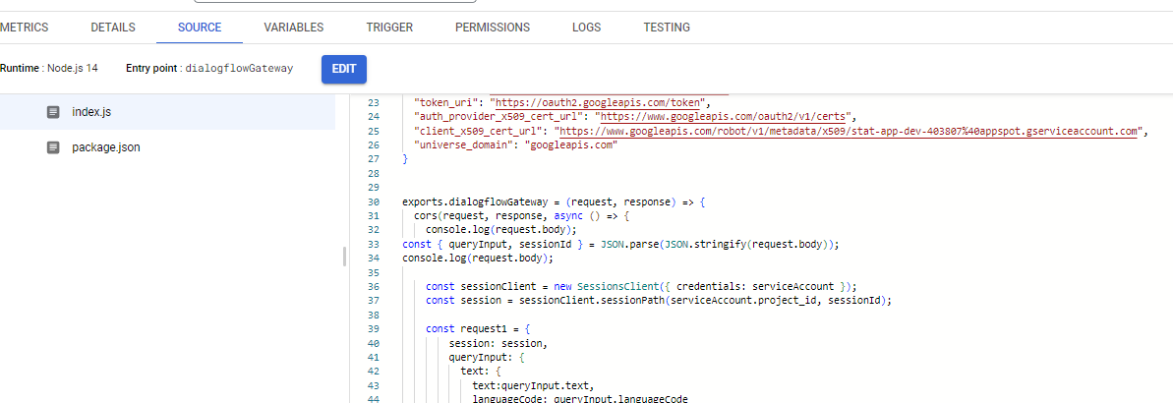

1. Now click on deploy.
2. After cloud function deployed we need to give all user permissions for the cloud function and need to give permissions for service account.
3. All user permissions means, Everyone can access

